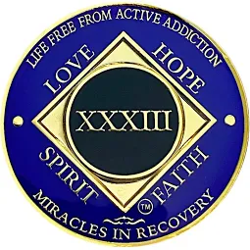 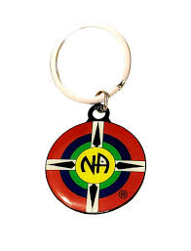

***New Beginnings Group of NA celebrates it’s 33rd Anniversary***



***5th Tradition, Each group has but one primary purpose to carry the message to the addict who still suffers.***

***DATE: March/1/2025***

***Serving starts at 6pm,Than History & Speaker 7pm after Speaker ---- Dance.***

***Address : AMERICAN LEGION POST 43***

***300 S McLewean St, Kinston, NC 28501. Contacts: Alvina D. (252) 775-9062 --- Drew M. (631) 882-1602***